1. confidence interval (CI)

Question: The Environmental Protection Agency (EPA) is concerned about the amounts of PCB, a toxic chemical, in the milk of nursing mothers. In a sample of 20 women, the amounts (in parts per million) of PCB were as follows:

16,0,0,2,3,6,8,2,5,0,12,10,5,7,2,3,8,17,9,1

Use these data to obtain a

**(a)** 95percentconfidenceinterval

**(b)** 99percentconfidenceinterval

of the average amount of PCB in the milk of nursing mothers.

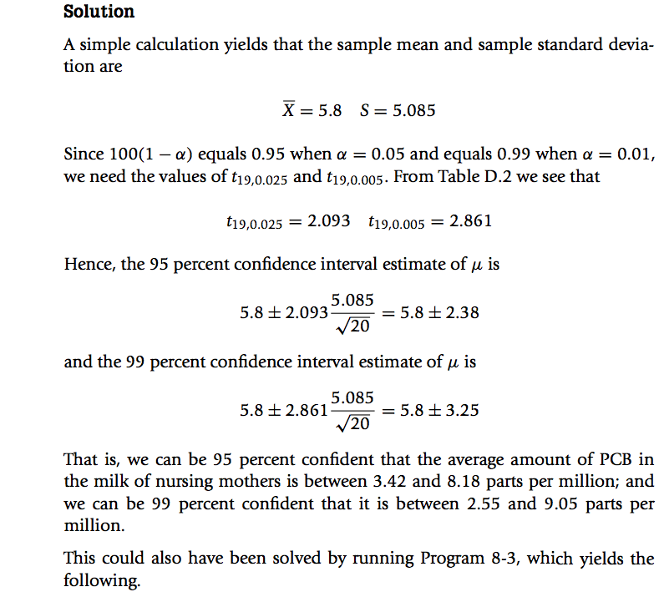

--------Introductory statistics (Sheldon M.Ross, third edition)

1. Testing hypothesis

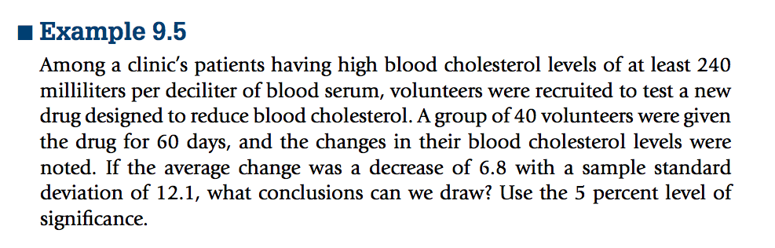

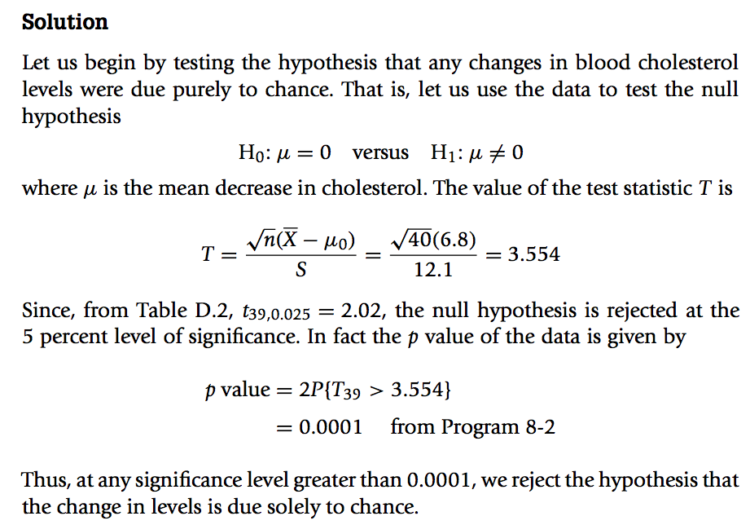

--------Introductory statistics (Sheldon M.Ross, third edition)

1. maximum likelihood estimate

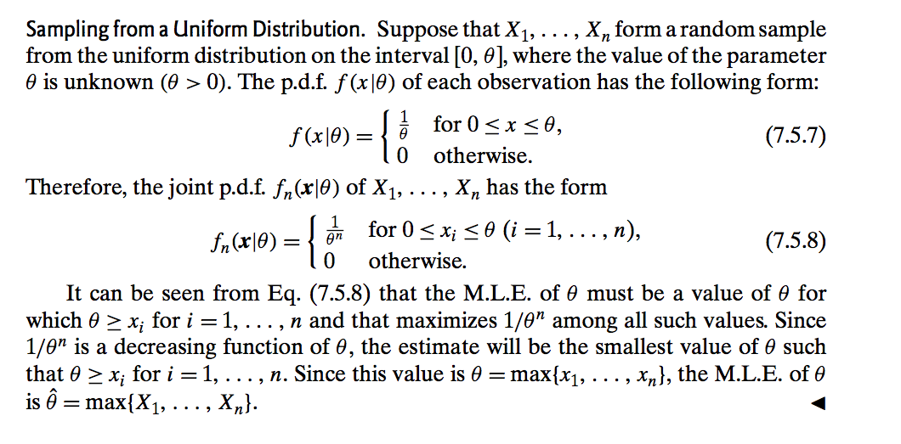

-----Probability and Statistics(morris H.degroot, mark J.schervish, fourth eidition)

1. convergence in probability

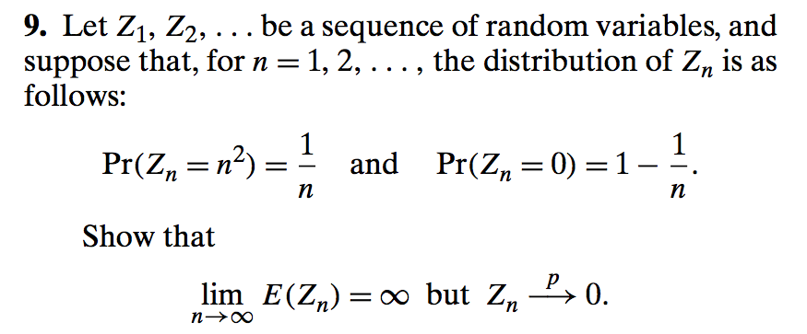

-----Probability and Statistics(morris H.degroot, mark J.schervish, fourth eidition)

Solution:

Because $\lim_{n→∞}{E\left(Z_{n}\right)=\lim_{n→∞}{(\frac{1}{n}×n^{2}+0×(1-\frac{1}{n})})=∞}$

However $\lim_{n→∞}{\operatorname{Pr}\left(Z_{n}=n^{2}\right)=\lim_{n→∞}{\frac{1}{n}=0}}$

$\lim_{n→∞}{Pr⁡(Z_{n}=0)}=\lim_{n→∞}{1-\frac{1}{n}=1}$

So $Z_{n}\underset{→}{p}0$

1. chi- square test

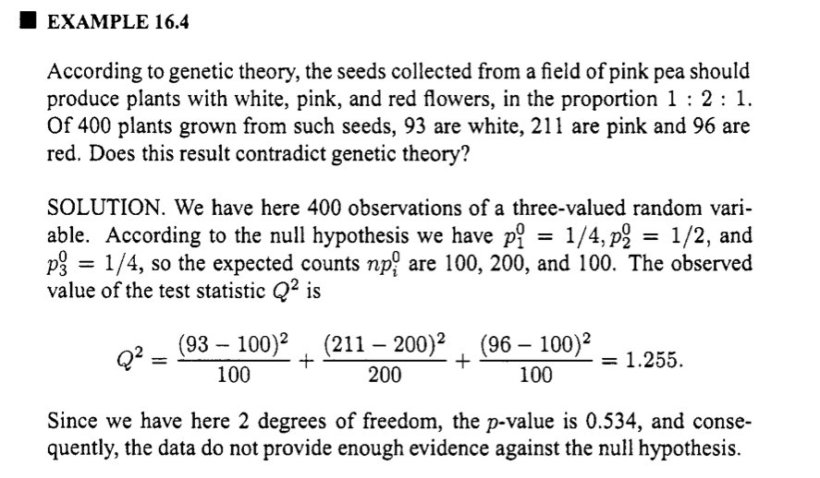

----------probability and statistical inference (Robert Bartoszynski, Magdalena Niewiadomska-Bugai, second edition)

1. chi- square test

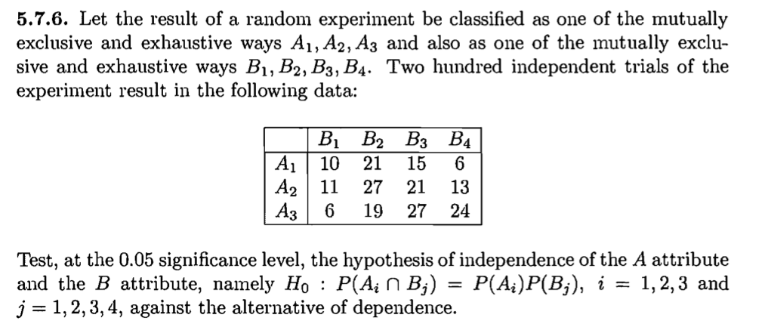

---------introduction to mathematical statistics sixth edition and solution

Solution:

$$P\left(A_{1}\right)={(10+21+15+6)}/{200}=0.26$$

$$P\left(A_{2}\right)={(11+27+21+13)}/{200}=0.36$$

$$P\left(A_{3}\right)={(6+19+27+24)}/{200}=0.38$$

$$P\left(B_{1}\right)={(10+11+6)}/{200}=0.135$$

$$P\left(B_{2}\right)={(21+27+19)}/{200}=0.335$$

$$P\left(B_{3}\right)={(15+21+27)}/{200}=0.315$$

$$P\left(B_{4}\right)={(6+13+24)}/{200}=0.215$$

Because ${ H}_{0}:P\left(A_{i}∩B_{j}\right)=P(A_{i})P(B_{j})$

So $χ^{2}\left(6\right)=\sum_{i}^{3}{\sum_{j}^{4}{(X_{ij}-P_{i}P_{j}×200)/(P_{i}P_{j}×200)}}=12.9$

Because 0.05=12.6 < 12.9

So reject H0 at the significance level of 0.05 and view that it isn’t independent.