The Annual Report
Society for Industrial and Applied Mathematics
KU Student Chapter

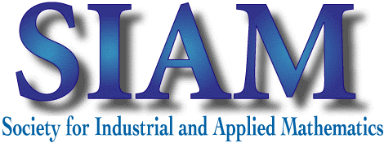

Prepared by:
AWM KU Student Chapter President Cassidy Krause
and
SIAM KU Student Chapter President Alec Knutsen

Academic Year 2017-2018

Contents

Executive Summary and Brief History 3
List of Student Officers and Faculty Advisors 5
Summary of Meetings, Fall 2017 6
Summary of Meetings, Spring 2018 10
Executive Summary and Brief History

SIAM was incorporated in 1952 as a nonprofit organization to convey useful mathematical knowledge to other professionals who could implement mathematical theory for practical, industrial, or scientific use. Since then, SIAM’s goals have remained the same. The KU Student Chapter of SIAM had its first year this year in 2018!
The KU SIAM student chapter has the purpose of improving the application of mathematics and computational science in a variety of disciplines including but not limited to: engineering, statistics, physics, computer science, and economics. Our goal is to establish communication , collaboration , and connections between fellow members, other student chapters, and departmental faculty. Furthermore, the chapter aims to foster creativity, intrigue, and the cultivation of ideas and learning in applied mathematics.
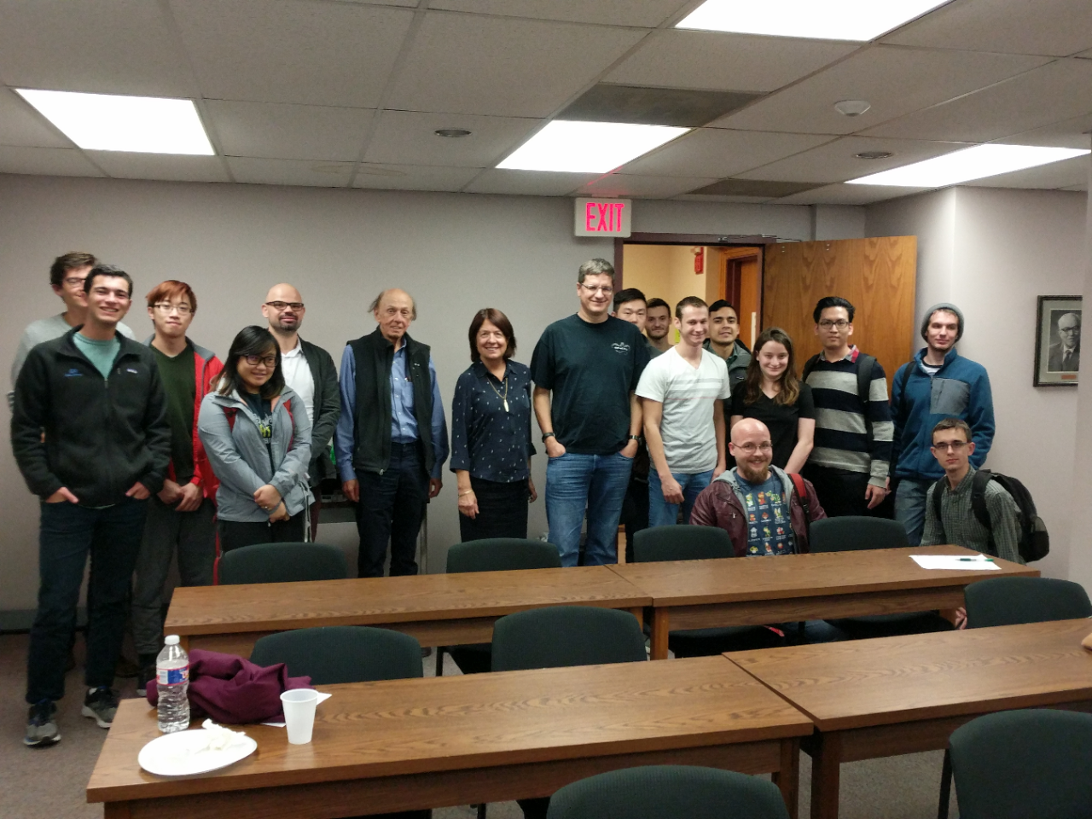
A meeting of the KU Student Chapter of SIAM
To accomplish these goals, the KU Student Chapter of the SIAM has regular meetings for its student members and faculty mentors. At these meetings, we address issues that are related to the organization, build the network and relationships amongst the members, and have conversations with invited guests, During these guest lectures, students and faculty have the opportunity to learn about careers in STEM and celebrate the accomplishments of successful mathematicians and scientists.

In addition to these meetings, the KU Student Chapter of the SIAM provides assistance to the Mathematics Department at KU in its outreach programs, most notable of which happen during Mathematics Awareness Month (MAM) in April 2018. There are several activities that take place during MAM: there is a proclamation at city hall, KU hosts a math competition for elementary school students, and the graduate students invite local fifth graders to come and spend a morning doing fun math activities.
List of Student Officers and Faculty Advisors
Academic Year 2017-2018

Position | Name | Email
President | Alec Knutsen | aqknutsen@gmail.com
Vice President (Graduate) | Kaleb Goering
Secretary | Nick Oderio | ncoderio@ku.edu
Treasurer | Jill Vesta | jevesta@ku.edu
Webmaster | Alec Knutsen | aqknutsen@gmail.com
Vice President (Undergraduate) | Andrew Barlow | a020b032@ku.edu
Economics Liaison | Logan Hotz | l887h429@ku.edu
Physics Grad Student Liaison | Sarah LeGresley | slegres@ku.edu

Faculty Advisor | Email Address
Prof. Bozenna Pasik-Duncan | bozenna@ku.edu
Faculty Members | Email Address
Prof. Agnieszka Miedlar | amiedlar@ku.edu
Prof.Tyrone Duncan | duncan@ku.edu
Administrative Support | Email Address
Gloria Prothe | kumath@ku.edu
Kerrie Brecheisen | kbrech@ku.edu

Tuesday, October 10, 4:15 pm
306 Snow Hall

“Conversations with Dr. Rebecca Peterson, Director of Development and Foundation Relations, KU Office of the Provost”

Rebecca Peterson, PhD
University of Kansas

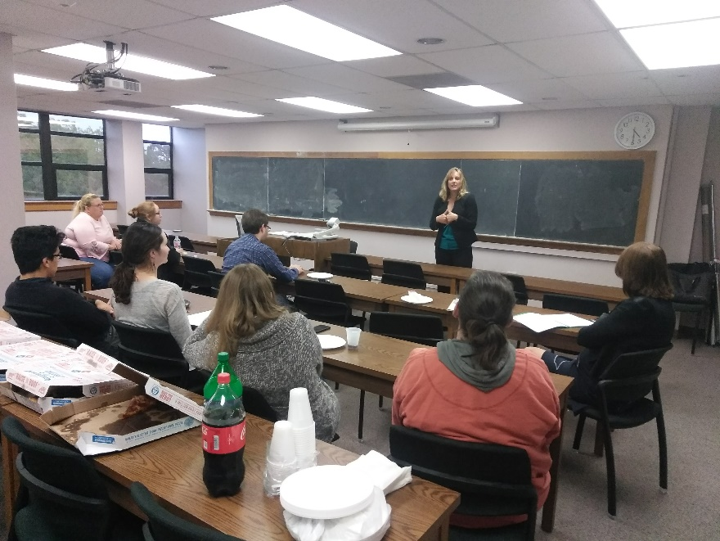
Dr. Peterson giving her talk at the AWM and SIAM meeting

Dr. Peterson joined us for a conversation about external funding and career advancement. Some advice she gave was to be careful about prioritizing your time, and be aware of who you are giving your time to. She also talked about the struggles of negotiations for women, and gave advice on how to overcome them. Finally, she gave advice on how the math department might seek funding for a youth math summer program.

Tuesday, October 23, 4:15 pm
306 Snow Hall
“A Conversation with Dr. Joy Kirsten Ward”

Joy Ward, PhD
CLAS Associate Dean for Research
Professor of Ecology and Evolutionary Biology
University of Kansas

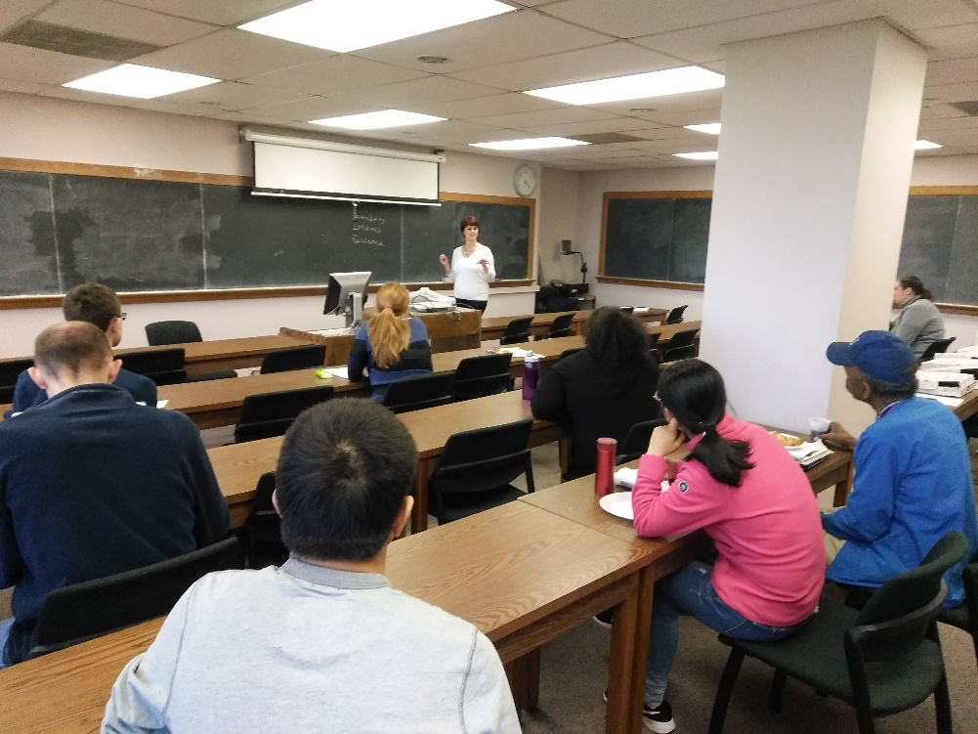
Dr. Ward talking with students about career advancement
Dr. Ward spoke to the AWM chapter and SIAM chapter about important characteristics to develop throughout one’s career and how they can play an important role in shaping one’s path. Dr. Ward introduced herself and talked about her background. She then, through personal anecdotes, discussed topics like serendipity, instinct, and resilience during her career. For each of these topics, the audience split into small groups and further discussed these ideas in their own life/career; some examples were shared with the whole group. Dr. Ward ended the presentation by answering some questions, which covered topics such as what the biggest challenges of her position are and awards and funds that come through her office.
Tuesday, October 31, 4:15 pm
306 Snow Hall

“How’s it Going and Where Is It Going To?”

Judy Roitman, PhD
University of Kansas, Professor Emeritus

Before this meeting, Dr. Roitman asked members of the AWM and SIAM student chapters to read the following article on women in math: https://www.thecrimson.com/article/2017/10/20/everyday-struggle-women-math/. During the meeting, we discussed this article and shared some of our own experiences of struggles with working in mathematics.
Dr. Roitman presented some national data on female students, women holding positions in the AMS, national data for women in mathematics form the undergraduate level to tenured faculty. She then discussed statistics concerning women in faculty positions (in academia) and briefly mentioned the situation for women outside of academia. Dr. Roitman also spoke about the issues of treatment and behavior toward women in and out of the workplace. The audience then divided into small groups and shared personal examples relating to topics discussed, experiences with micro aggressions, and concluded with some examples shared with the whole group.

Wednesday, November 29, 4:15 pm
306 Snow Hall

“Conversations with Dr. Brian McClendon, Member of National Academy of Engineering”

Brian McClendon
University of Kansas
Electrical Engineering and Computer Science

Brian McClendon joined us for a joint meeting with the KU SIAM Student Chapter. He talked about his career trajectory and his relationship with mathematics and computer science. He had lots of advice for students who planned to pursue a career in industry, and he talked about his experiences working with Google Maps, Uber, and at KU. He also discussed the importance of communicating science and math to the public, and shared his opinions on the future of artificial intelligence and machine learning.

April 2018
Math Awareness Month Activities

April is Math Awareness Month, and the AWM partnered with the Math Department and the KU Math Graduate Student Organization to host a variety of activities and outreach events. There was a proclamation at Lawrence City Hall to announce April as Math Awareness Month, and KU hosted a math competition for elementary school students from all over the state.
We also hosted local 5th grade students on April 11th and April 18th. Graduate students spent the morning doing fun math activities with these students, including: creating algorithms and making paper planes; map coloring and the 4-Color Theorem; exploring the relationships between distance, rate, and time through races; and logic puzzles.

Friday April 20, 2:00 pm
408 Snow Hall

“Conversations with Dr. Cleve Moler, Chief Mathematician, Chairman, and co-founder of MathWorks”

Cleve Moler, PhD
MathWorks
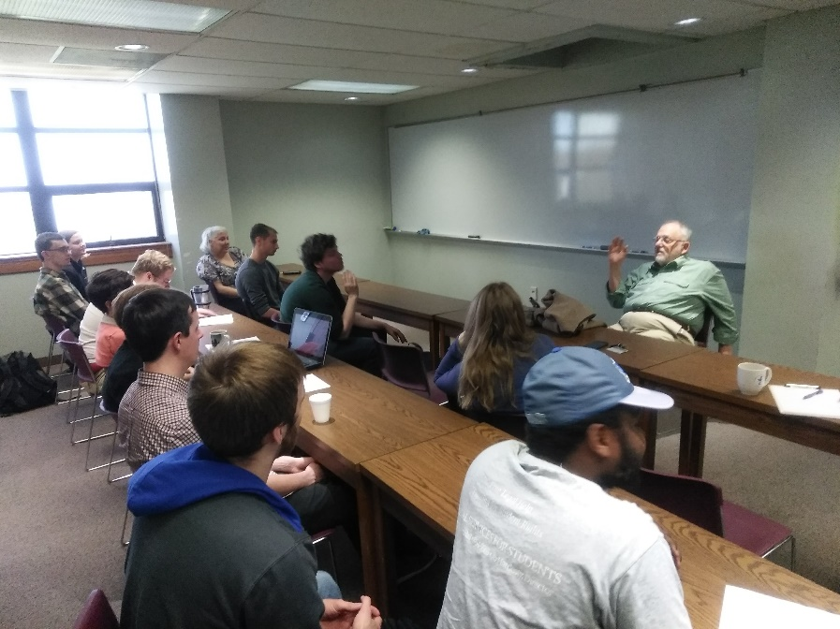

Dr. Moler having an informal conversation with students

Dr. Moler came to KU to give the Russell Bradt Undergraduate Colloquium on April 19, and graciously agreed to meet with students on the following day. He talked about his experiences as one of the original founders of Matlab, and he advertised some positions that were open in MathWorks. He was very interested in the students, and gave advice about pursuing careers in industry, government, and academia, as he had worked in all three areas.

Tuesday, May 1, 4:15 pm
306 Snow Hall

“Celebrating Graduates and the End of the Academic Year”

Joint Meeting of SIAM Student Chapter and AWM Student Chapter
University of Kansas

During our final meeting of the year, we each discussed what we had done during the past year and what our plans were for summer or after graduation. Bozenna Pasik-Duncan talked about her amazing experience as the 2017-2018 Global Chair of IEEE Women in Engineering (WIE) organization, in which she oversees over 800 Affinity Groups around the world with over 22,000 members. She spoke passionately about the WIE International Leadership Conference (ILC) and 11 WIE International Leadership Summits on six continents. She encouraged us to speak up to make a change in the world. She recommended the book Make Trouble by Cecile Richards, and talked about her experiences with IEEE and their leadership summits.
Emily Witt mentioned the national AWM mentoring program as an opportunity that we might want to get involved with. Other students talked about interview they had recently, and how involvement with AWM and other groups helped them do well in their interviews.

